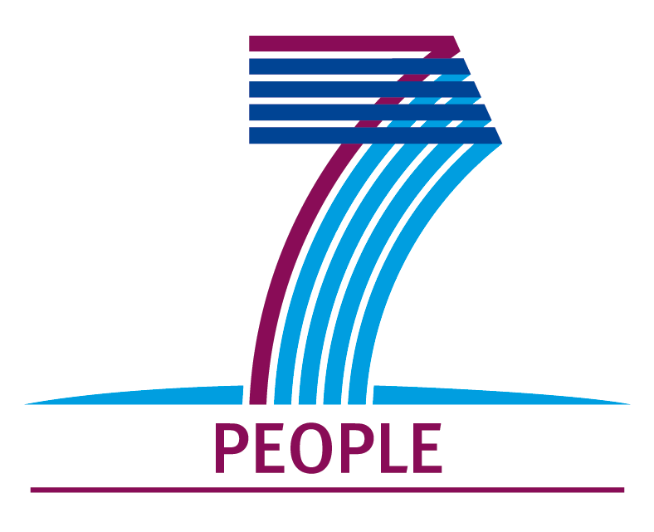
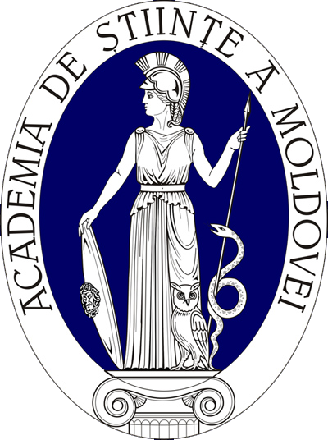
Academy of Sciences of Moldova
FP7 National Contact Point

1, Stefan cel Mare Ave.
MD-2001, Chisinau
Republic of Moldova
Tel/fax: +37322-270502
elena.severin@asm.md
web: www.asm.md /
international.asm.md

EU Seventh Framework Programme
Call Identifier FP7-PEOPLE-2009-IRSES

International Research Staff Exchange Scheme
PARTNER SEARCH FORM

Date
Area | Chemistry CHE  Social and Human Sciences SOC  Economic Sciences ECO  Information Science and Engineering ENG | Environment and Geosciences ENV  Life Sciences LIF  Mathematics MAT  Physics PHY
Name of the Organization
Organization Type | University  Research Institution  Academy |  | Laboratory  International Organization  Association
IRSES Project Abstract
Expected expertise
International projects already undertaken

Contact Details
Name, Surname:
Address:
Phone:
Fax:
E-mail:
Web Adress

If you are interested in taking part in this project, please return to the contact above and intcol@asm.md

