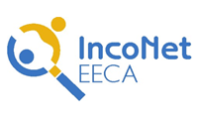
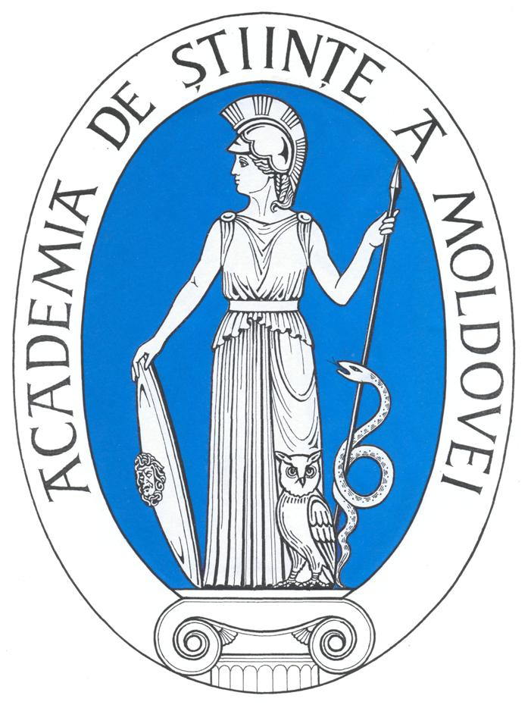
S&T International Cooperation Network for
Eastern European and Central Asian Countries

Workshop
EU-EECA cooperation in Human Genomics and related Health issues
Chisinau, Republic of Moldova
April 28-29, 2009

PARTICIPATION FORM

Please complete this form and send it by 20th of March 2009
by email to intcol@asm.md
Last name |  | First name
Institution
Position
Experience in EU Framework Programmes
Address
City |  | Country
Tel. |  | E-mail
Fax |  | Website

Please enclose a three page (max.) CV describing your research experience.

