
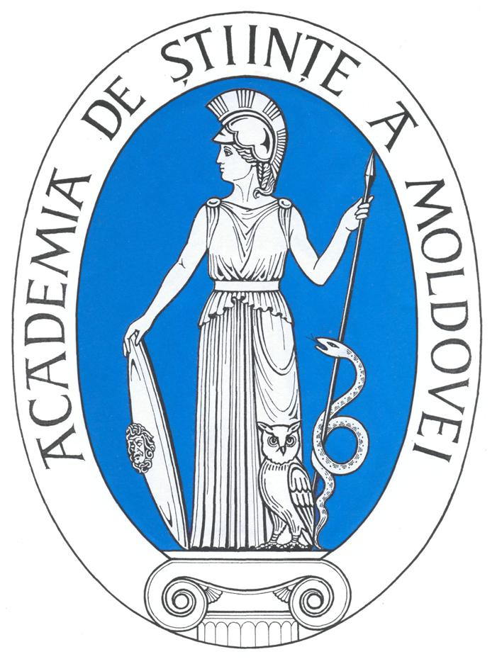

S&T International Cooperation Network for
Eastern European and Central Asian Countries

Workshop
EU-EECA cooperation in Human Genomics and related Health issues
Chisinau, Republic of Moldova
April 28-29, 2009

The Workshop on Human Genomics & Related Issues is organised in the framework of the IncoNet EECA project (S&T International Cooperation Network for Eastern European and Central Asian countries), funded through the 7th Framework Programme for Research and Technological Development of the European Community (FP7).

The workshop has the aim to bring together stakeholders from the scientific community and S&T intensive industry of the Eastern European and Central Asian Countries (EECA)*

and of EU Member States and Associated countries to
- identify research topics of EU-EECA mutual interest addressing at the same time the strengths and needs of the EECA and
- provide input to the European Commission and to the Health Programme that could be used for the definition of Specific International Cooperation Activities (SICA) to be included in future Health Work Programmes.

Human genomics has been selected as the main topic to be addressed by the workshop, focusing especially on:
- monogenic and polygenic pathology;
- environment and human genetics;
- population genetics.

To ensure the success of the workshop, stakeholders from all EECA countries are invited to participate. The participation costs (flight, accommodation for three nights in the period of 27 – 30 of April, meals during the two working days of the workshop) for selected participants will be covered from the budget of the IncoNet EECA project. The working language for the workshop will be English. The selected participants will be asked prior to the meeting to prepare a brief input on sub-topics that could be of particular interest for EU-EECA cooperation. In addition they will be asked to contribute to the written conclusions of the workshop.

Please return the filled-in form by 20th of March to intcol@asm.md attaching also a brief CV (up to 3 pages) that should highlight your experience in the aforementioned topics, as well as: previous involvement in FP or other multilateral cooperation programmes, a broader knowledge on activities related to the topic in your country or in the region, etc. The participants will be selected by the organizers and the European Commission in view of the optimum coverage of the topic and of a broad representation of the countries involved.
ORGANIZING COMMITTEE:

Academician Gheorghe DUCA, President of the Academy of Sciences of Moldova
Corresponding member Ion TIGHINEANU, Vice-President of the Academy of Sciences of Moldova
Corresponding member Stanislav GROPPA, State Medical and Pharmaceutical University “N.Testemitanu”
Corresponding member Maria DUCA, Rector of the University of the Academy of Sciences of Moldova
Prof. Nicolae BARBACAR, Institute of Genetics and Plant Phyisiology of ASM
Prof. Veaceslav MOSIN, Directorul Centrului Naţional de Sănătate Reproductivă şi Genetică Medicală
Dr. George BONAS and Dimitris FILIPPIDES, International Centre for Black Sea Studies (ICBSS)
Dr. Indridi BENEDIKTSSON - DG Research, European Commission
Sergiu PORCESCU, Academy of Sciences of Moldova
Elena SEVERIN, Academy of Sciences of Moldova

* EECA Countries: Armenia, Azerbaijan, Belarus, Georgia, Kazakhstan, Kyrgyzstan, Moldova, Russian Federation, Tajikistan, Turkmenistan, Ukraine, Uzbekistan.

